CHINMAYA INTERNATIONAL RESIDENTIAL SCHOOL
COIMBATORE

SAMPLE PAPER – 2010
CLASS : 08 SUBJECT: SCIENCE

- What kind of circuit do you see in the picture given below?

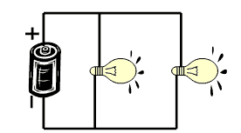

  - Open Parallel Circuit
  - Close Serial Circuit
ANSWER
  - Open Serial Circuit
  - Close Parallel Circuit

- The remains of plants and animals in the soil are called

  - Humus
  - Crystals
  - Clay
  - Silt
ANSWER

- What kind of force is there between the two celestial objects shown in the above picture?

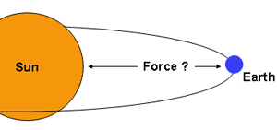
  - Electrical
  - Magnetic
ANSWER
  - Nuclear
  - Gravitational

- The element which is required in largest quantity by plants is
  - Sulphur
  - Calcium
  - Nitrogen
ANSWER
ANSWER
ANSWER
  - Phosphorous

- Which one of the following is an edible fungi?

  - Penicillium
  - Agaricus
  - Yeast
  - Bread Mould

- Dry ice is the solid state of

- H₂O
- CO₂
- NaCl
- NH₃

